**Lab 6 - Precision Control**

Austin Huang and Matthew Rodriguez

**Figures**

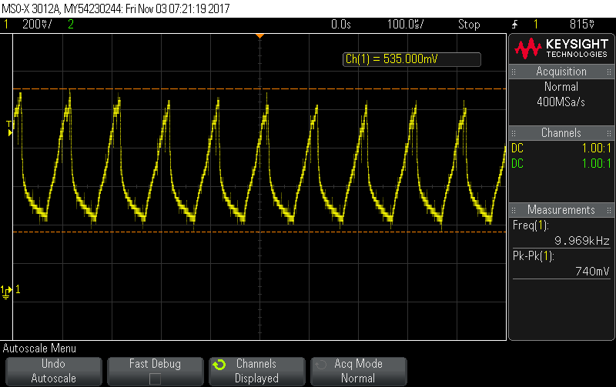

Figure 1.  Triangle Wave Output of the 10kHz Input.

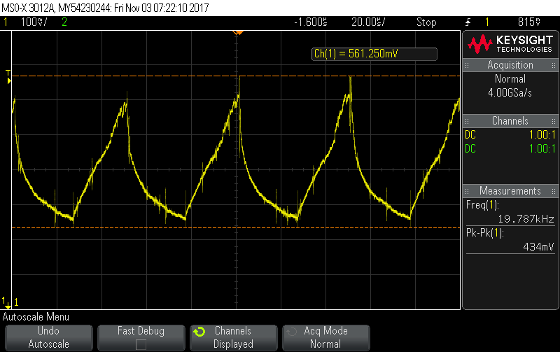

Figure 2.  Triangle Wave Output of the 20kHz Input.

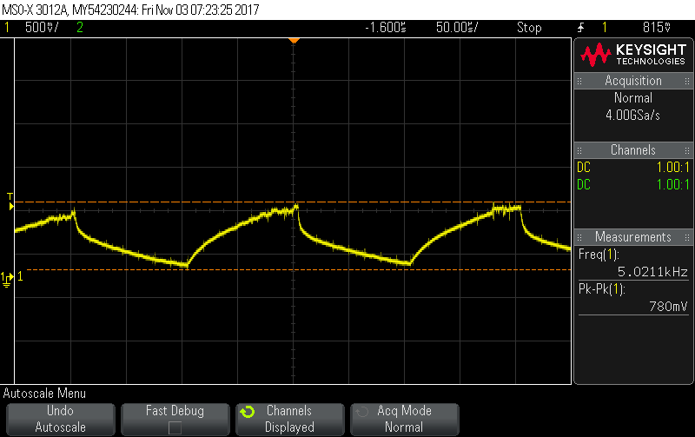

Figure 3.  Triangle Wave Output of the 5kHz Input.

|  |  |  |
| --- | --- | --- |
| Theoretical Input | Theoretical Output | Actual Output |
| 01001110 | 1.469V | 1.473V |

Figure 4: Output for Digital to Analog Converter

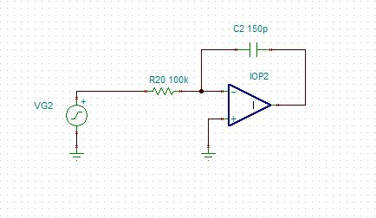

Figure 5: Tina-Ti schematic of Integrator with PWM input

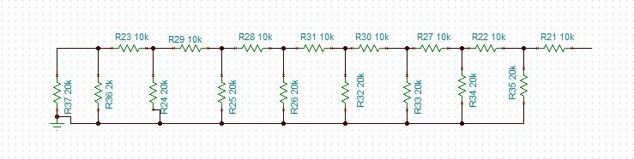

Figure 6: Tina-Ti schematic of R2R DAC ladder

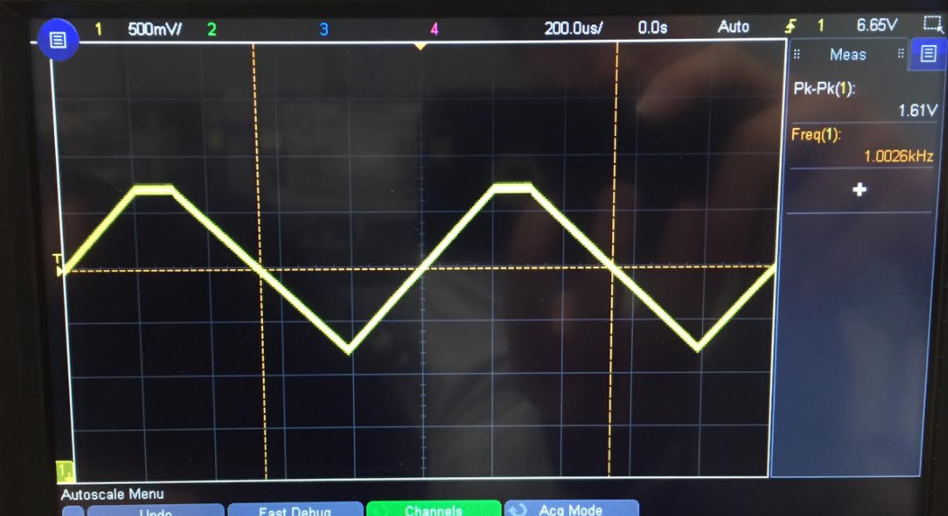

Figure 7: Output of PWM circuit with no load

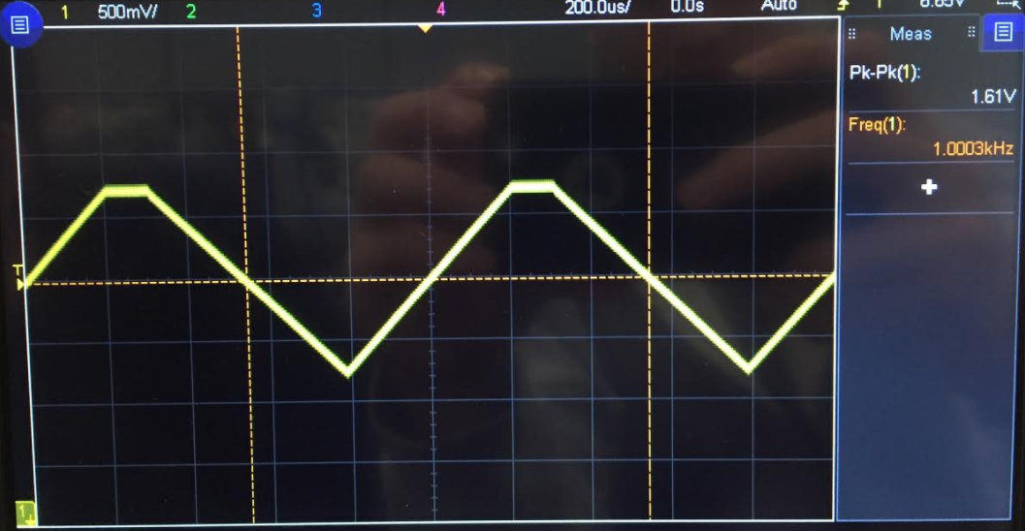

Figure 8: Output of PWM circuit with 100Ω load

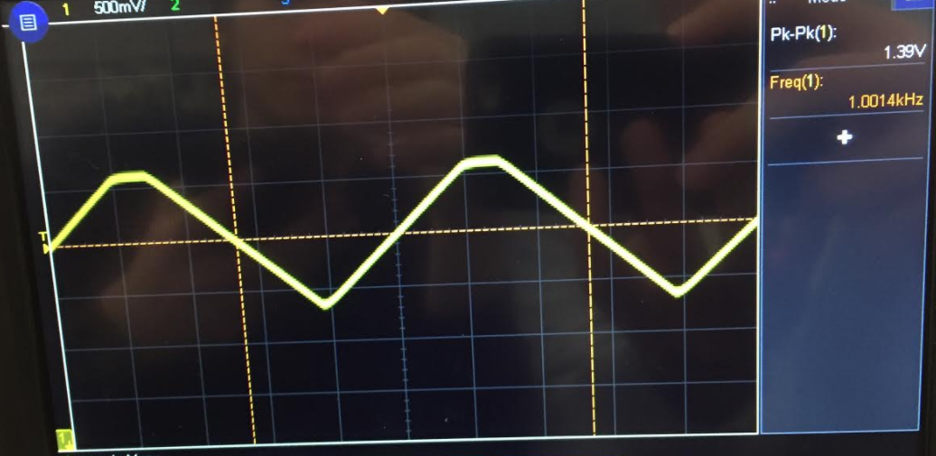

Figure 9: Output of PWM circuit with 270kΩ load

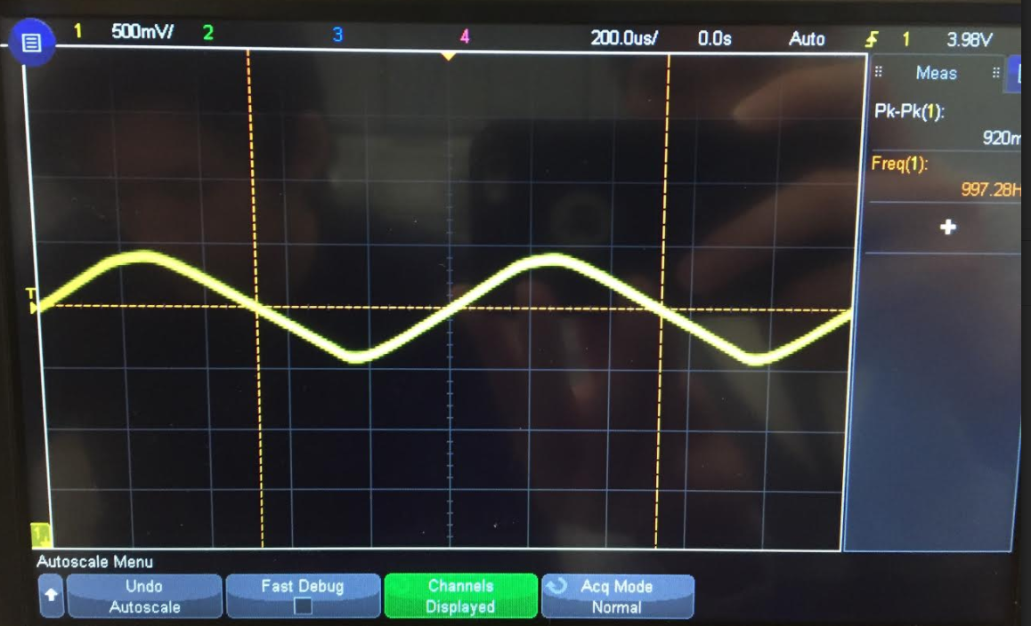

Figure 10: Output of PWM circuit with 820kΩ load

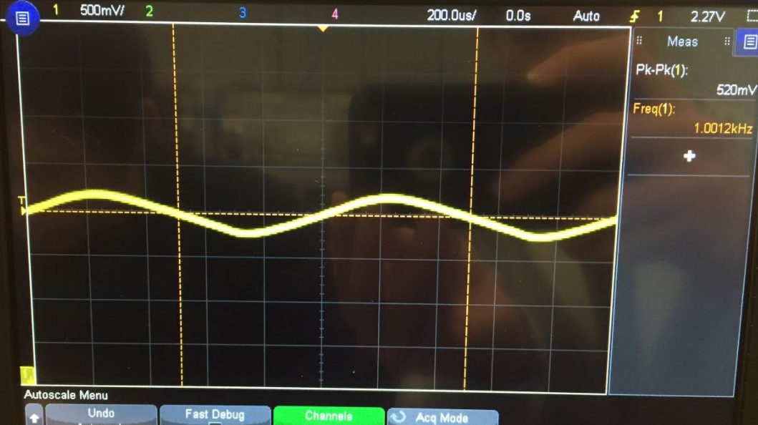

Figure 11: Output of PWM circuit with 2MΩ load

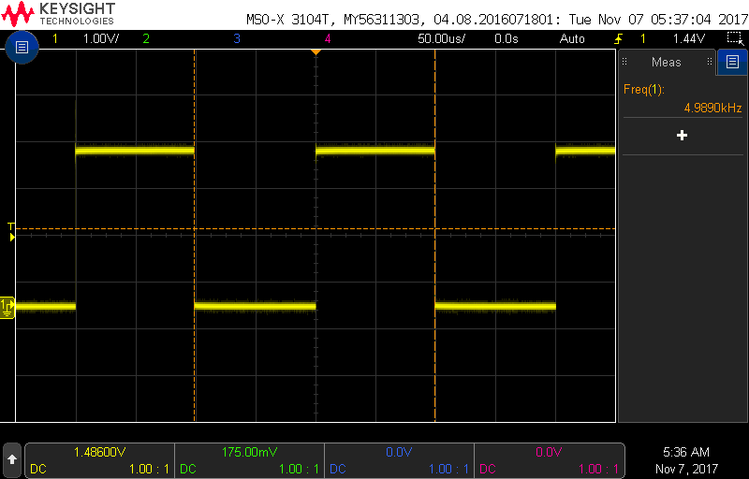

Figure 12: Input wave from MSP430 into PWM

|  |  |  |
| --- | --- | --- |
| # | Part | Quantity |
| 1 | TL072 | 1 |
| 2 | 20k Resistor | 11 |
| 3 | 10k Resistor | 7 |
| 4 | 1pF Capacitor | 1 |

Figure 13: Bill of Materials

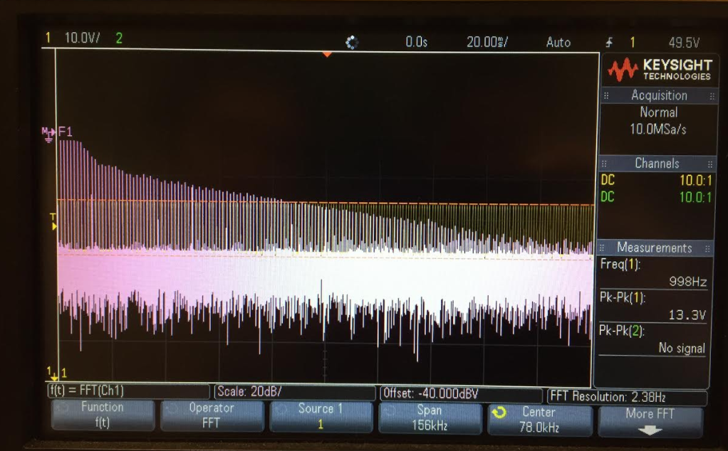

Figure 14: FFT of 1kHz signal

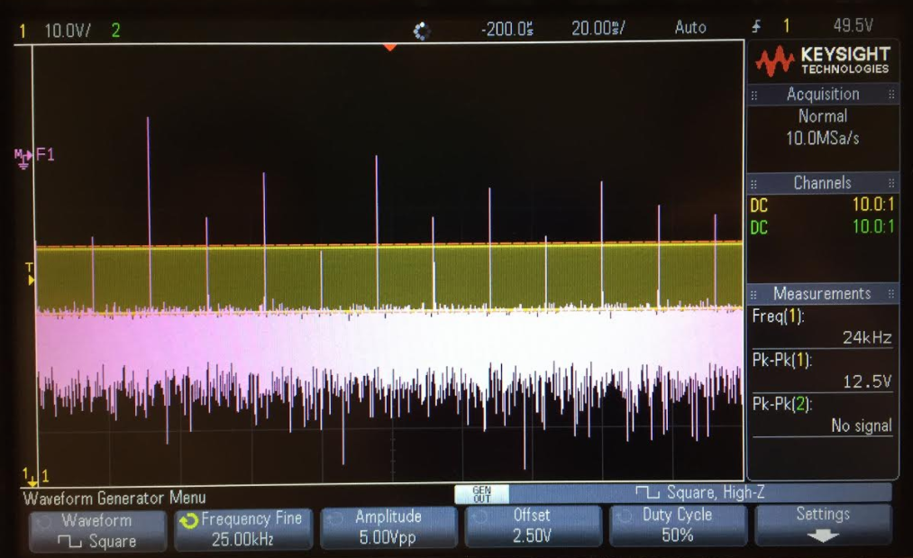

Figure 15: FFT of 25kHz signal

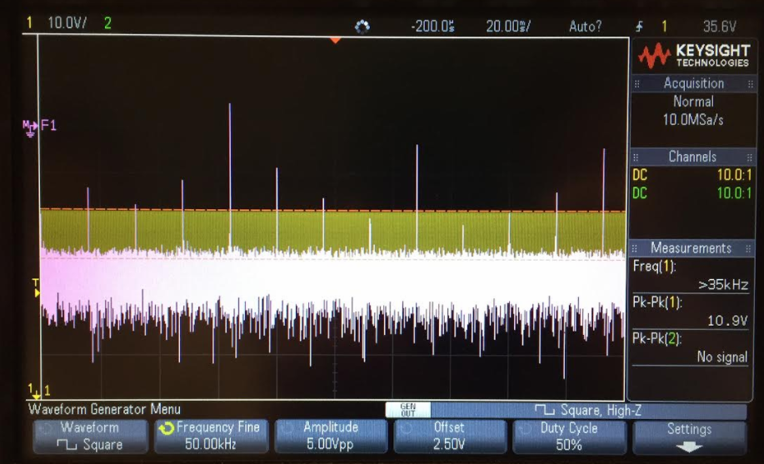

Figure 16: FFT of 50kHz signal

**PWM Part 2**

A circuit was built to handle the PWM wave input from the MSP430. The circuit designed was an integrator to handle the AC wave. The circuit schematic constructed in Tina-Ti can be seen in Figure 5. The input from the MSP430 instead of the waveform generator to the circuit can be seen in Figure 12.

The output of the MSP430 was set to be a square wave. Because the input (Figure 12) to the circuit from the MSP430 was a square wave, the integration expected would be a triangle wave. The triangle wave outputs can be seen in Figures 1-3 for each of the frequencies. Figure 1 shows the triangle wave output of the 10kHz input. Figure 2 shows the triangle wave output of the 20kHz input and Figure 3 shows the 5kHz input. Thus, the recorded measurements confirm the functionality of the low-pass filter.

The same integrator was tested with varying frequencies on the oscilloscope using the FFT. The FFT results collected at 1kHz, 25kHz, and 50kHz are seen in Figures 14-16.

**R2R DAC**

A circuit was designed to convert the digital output of the MSP430 to an analog DC signal The theoretical output was expected to be 1.469V given an input of 01110010 (114) from the MSP430.

Each resistor in an R2R ladder will split an incoming voltage by some power of 2. The resistor farthest from your output will be controlled by the least significant bit, and will contribute the least voltage if on. (if off, it will contribute nothing.) The resistor closest to your output will be controlled by the most significant bit, and will contribute the most voltage if on. The specific amount of voltage each resistor contributes is the total voltage divided by 2 to the power of the bit’s place in the binary number from left to right. The most significant bit has a place of 1, the second most 2, etc. In an 8 bit DAC R2R convertor, the most significant bit will contribute half the voltage if on, (total voltage / 2^1) and the least significant bit will contribute the total voltage divided by 2^8, or 1/256 of the total voltage. Thus, our input of 01110010 was expected to be 57/128 of the total voltage. (1/128 + 8/128 + 16/128+ 32/128) The least significant on bit, having a place of 7 in terms of significance, was used as the reference. (1/2^7)

This was tested by the circuit built from the Tina-Ti schematic shown in Figure 6. The result is shown in Figure 4. The result is near the expected voltage.

**Loading Effects**

A model in TINA-TI was built to analyze the loading effect of the boards as seen in Figure 5 except the input of the circuit was created by the waveform generator instead of the MSP430. The input of the circuit was set to a 50mV PP square wave. The circuit was then tested with varying resistor values 100Ω, 1kΩ, 270kΩ, 840kΩ, and 2MΩ as the load to observe the loading effect. Initially, the test did not involve a load. A signal was sent from the MSP430 and the output was directly measured from the output of the op amp as seen in Figure 7. This produced a triangle wave, since the circuit involved integrating a square wave.

The output without the load was used as a reference to see the effects of bigger and bigger loads on the circuit output. The output of the circuit with a 100Ω load is seen in Figure 8. It is seen to match the output of the reference (no load) exactly. The output of the circuit with a 270kΩ load is seen in Figure 9. A noticeable difference is observed as the output voltage is less than the reference. (1.39VPP compared to 1.61VPP) To further test a larger load, an 820kΩ resistor is used. The output is seen in Figure 10. It produces a 920mVPP output as opposed to the 1.61VPP reference. Out of curiosity, a very large resistor value of 2MΩ was used to observe the output. It produced an output of 520mV as seen in Figure 11 which is significantly smaller than the original output with a small or negligible load.

This experimentation allows for consideration for higher level design. Considering the loading effect of very large or very small loads is an integral part of circuit design.

**Bill Of Materials**

The bill of materials for necessary equipment to complete this lab experiement is shown in Figure 13. Below is a link to a DigiKey cart to purchase the materials.

http://www.digikey.com/short/q3450w